Quiz 1

Q1) Indentify where state machine will stuck !!!

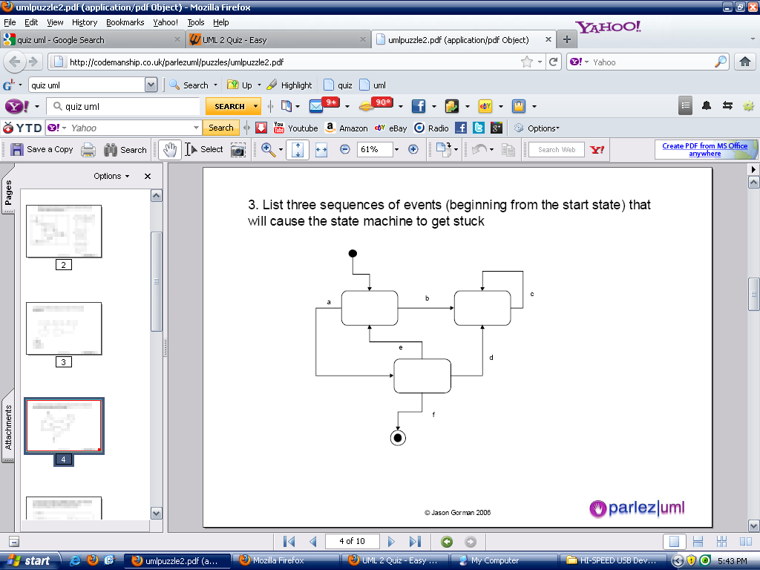

Q2) What is self association relationship

